"COMMON PRACTICE 11 FOR ACCURATE END OF LIFE MANAGEMENT OF LOGIC PRODUCTS

The Logic's products have a very long life cycle and they can be submitted to maintenance on condition, so to guarantee that the product is maintained for a long time.

This allows, for example, reducing waste production.
However, once the product has reached the end of its life, it is necessary to respect some simple rules to support the principle of the Circular Economy and to avoid harmful impacts on the environment.

Recycling is the recovery of material from waste. The recycling wastes must be treated by authorized subjects in accordance with the local regulation of the country where the item is alienated.
The products developed by Logic can contain different types of materials, many of them are recyclable, others are potentially dangerous far the environment.
In particular, the standard modular design for maintenance approach allows to separate the metallic housing (typically aluminum) from the internal electronic board.
Please note that the majority of the products have the soldering of the electronic component performed with Sn63Pb37 alloy, as a consequence all the appropriate action has to be considered for operating on item that includes leads.

For details and further information, refer to: support@logic-spa.com

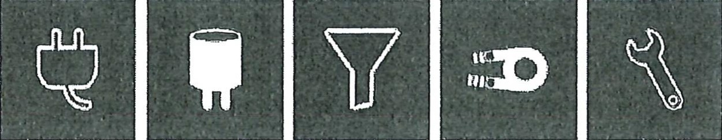
Cables Capacitor Plastic Ferrous Metals Non-ferrous Metals

The waste generated by Logic's products are components of electrical and electronic equipment and must therefore be delivered to authorized carriers and disposers for these specific types of waste.

Batteries and accumulators, present only in the product of the following families PEF, PEC, FEF, DAU and DAB, must be disposed separately.

